Dear
I’ve got big plans for you and they do not stop when bad things are happening. Long before you were born I worked out the details of your life. I did not only make you unique as a person, but I also created you with a very special plan for your life.
I had big plans for Joshua too. He would lead the Israelites into the Promised Land and they would take possession of it all. When some of them doubted my plans, Joshua and Caleb did not. They believed and trusted me that I would do as I say.
You cannot see the whole picture but trust and be confident that I do. For I know the plans I have for you, plans to prosper you and not to harm you, plans to give you hope and a future (Jeremiah 29:11).
Love Forever
God

P.S.
If you want to write a letter back to me, telling me how thankful you are that I have a plan for your life, pen it down in your prayer journal. Don’t forget to read it to Me before you go to bed.
OR
Create the binoculars of faith to help you to see My plan for your life.

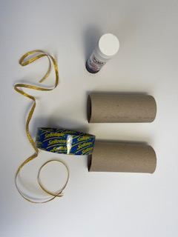
You will need two toilet tissue rolls, glue, sellotape and a piece of string.
Decorate the two toilet tissue rolls. You can paint them, stick coloured paper, wrap them in aluminium foil or anything by your choice.
Put glue on one side of each roll and stick them together.
Using sellotape attach each end of the string to the opposite sides of the binoculars so that you can hang them on your neck later.
Decorate the binoculars in your unique style. God’s plan for you is absolutely unique!
It is time to use the binoculars! After you colour the colouring page from the letter stick it to the wall. Put next to it your picture. Now step back as far as you can and try to see through the binoculars. Can you see Joshua and Caleb? And can you see yourself? Rest assured my child! The same way I saw Joshua and Caleb and had a plan for them to enter the Promised Land, I have a plan for you! You can only see it through the binoculars of faith. Trust me! I know my plans for you. Plans for a future and hope.
Instructions for the Binoculars of Faith

