**STILL TRYING TO DEFINE STEWARDSHIP?**

For me, [Galatians 2:20](https://biblia.com/bible/niv/Gal%202.20) is the key. It’s not a promise of hope, not a text of comfort, but a statement of my condition as a follower of Christ. “It is no longer I who live, but Christ who lives in me” (ESV). The metaphor I like to use is that of Christ managing my life. I am more than happy for Him to be my manager. The Person and Presence of Christ living in me allows for the supernatural to take over and manage my life. What more could I possibly want?

Everything would be perfect if it weren’t for the line “And the life which I now live in the flesh”. You mean to say there’s a problem with “the flesh”? Hmm, that’s a bit of a struggle at times. I love Paul’s letters for their honesty, but the moment he raises a problem, he finds the solution. The solution: “I live by faith in the Son of God, who loved me and gave Himself for me”.

John Stott defines grace as “love that cares and stoops and rescues.”1 In the context of stewardship, this is where the conversation starts. Since God has been so good to me, giving me Christ, then my response is to give my whole life back to God.

In football, the role of the manager is critical. When English club Manchester United was successful, it was because of the leadership skills of the manager, Sir Alex Ferguson. Under him, Manchester United was at its peak—the glory days, gaining cups and trophies every season. Since he left, new managers have come and gone, and so have the trophies!

Imagine what would happen to the church in our sphere of influence if we invited the Lord to be our Manager in a new, refreshing, and joyful way? What if we let Him take the lead to break through beyond slogans, religious clichés, and even our corporate strategy? Imagine a church—our church—where the problems of leadership, membership decline, lack of commitment, poor finances, and fragmentation were only historical conversations because God is totally in charge.

Frances R. Havergal’s hymn summarises the essence of Christian stewardship: “Take my life and let it be, / Consecrated, Lord, to Thee.” 2 I hope that I won’t just understand its meaning—but live it.*

1. John Stott, quoted in Justin Holcomb, “What Is Grace?” Christianity.com, accessed October 17, 2016, <http://www.christianity.com/theology/what-is-grace.html>.

2. Frances R. Havergal, “Take My Life and Let It Be,” Timeless Truths, accessed October 17, 2016, <http://library.timelesstruths.org/music/Take_My_Life_and_Let_It_Be/>.

* This week’s thought piece, was first published as an opinion for CQ, March 22nd, 2018 (adapted).

* **‘Motives of the Heart’ 3-minute video** with John Matthews who this week who admits that there’s lots and lots of different stewardship definitions.

[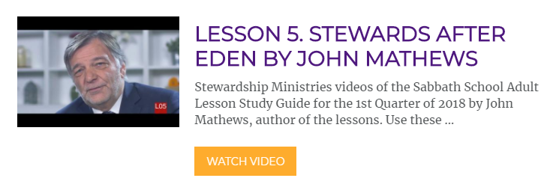](https://stewardship.adventist.org/online-videos?channel=1326917&video=247368143)

* 5 Q’s for Life Change

This week’s study: We can define stewardship, but what’s the consequence?

* Lesson Notes (attached): Created for those who want to dig deeper into the Word. Authored by Shevanthi Bastiam Pillai.  Class teacher or group leader?  Don’t miss these studies for providing both breadth and depth. Here’s a couple of gems from this week’s study that caught my attention:

“Every faculty you have, your power of thinking or of moving your limbs from moment to moment, is given you by God. If you devoted every moment of your whole life exclusively to His service, you could not give Him anything that was not in a sense His own already.  (C. S. Lewis, Mere Christianity).

*“As stewards of God, we will be expected to give an account of how we have managed the good gifts God has given us. These include our time, money, abilities, talents, knowledge, wisdom, relationships (spouse, children, colleagues), and positions of authority God has given us.”*

A prayer for you as you lead and teach.

All video introductions for this series of lessons can be found at: <https://stewardship.adventist.org/online-videos?channel=1326917>

With best wishes,

David