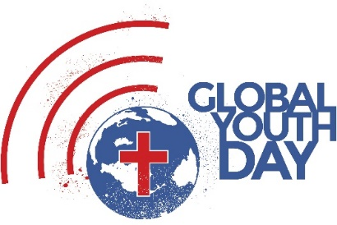
Trans-European Division
Global Youth Day Outreach Fund
Application Form 2019
Theme: Adopt

As you plan for the Global Youth Day in 2019, please take into consideration the following:
- Take the Master’s approach: “The Saviour mingled with men as one who desired their good. He showed His sympathy for them, ministered to their needs, won their confidence. Then He bade them, ’Follow Me!’”
- Observe before you plan: watch where most people are, what activities are they involved in, and what needs they have that you can meet.
- Discuss: after the observation exercise young people, form groups and discuss the most relevant real needs and by using their own spiritual gifts and abilities brainstorm about possible ministries which can meet some of the needs detected.
- Prepare: as soon as the group comes up with a practical ministry idea, they need to prepare the tools and supplies which are necessary to serve according to people’s needs. One very important ingredient is that the approach should be attractive to people, so they will come to you and ask questions rather than you going and trying to “sell” them something.
- Do it: go out and serve. Be a blessing and be the sermon to people around. Be ready to answer the questions: “Who are you?”, “Why are you doing this?”, and “How can I join you?”
- Evaluate and re-think: as soon as you have served and experienced the response of people, assess the attractiveness of the approach used, basically answer these two questions: “What went well?” and “How could we do it differently next time?”
- Do it again! Not only once a year! Evaluate, rethink, and do it again, and again – without routine.
These projects should be more than just a one-day event; we want to see them run long term - for the whole year. We are offering you the opportunity to apply for seed funding to get your long-term project off the ground.
Be creative: Approach ADRA, local authorities, charities and organisations that support & encourage community work and use the money to work alongside them.
If awarded the funding, you agree to send us 2 short video reports from your project – one by 30th June and the other by 31st December.
Send your plan and seed fund application to us no later than Monday 07 January 2019
E-mail to aagbaje@ted.adventist.org and jplaatjes@ted.adventist.org

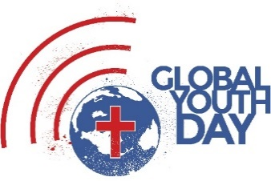
Approval and Funding Application

Country: Year of the outreach: 2019
Union/Field: Project Title:
City/Town: Project Director Name:
Project Director Email & Mobile Nr:
Media Contact Email & mobile Nr:
(actual person responsible for submitting videos)

Budget request in local currency:
Item 1:
Item 2:
Item 3:
Item 4:
Item 5:
Item 6:
Total:

Project Funding: Budget Contribution in local currency
Conference/Mission:
Union:
Division funding requested (max £1,000.00 GBP):

Project Description:

Ellen G. White, The Ministry of Healing, page 143.

