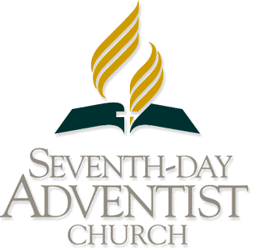
TRANS-EUROPEAN DIVISION

UNION APPLICATION FOR SPONSORSHIP ASSISTANCE
TO NEWBOLD COLLEGE

____________________________________________________________________________

Complete one form for each student name submitted for consideration for TED Sponsorship assistance. Please answer all the questions in full and return to the Trans-European Division office no later than Monday, 30th March 2020 for studies commencing in September 2020 (or 28th August 2020 for studies commencing in January 2021).

Please write in BLOCK CAPITALS

Name and Address of Union: _________________________________________________________
_________________________________________________________
_________________________________________________________
_________________________________________________________

Name of Student: _________________________________________________________

Email address of Student: _________________________________________________________

Name and Address of _________________________________________________________
Conference / Employing Organisation _________________________________________________________
of Student: _________________________________________________________
_________________________________________________________

 | STUDY PROGRAMMES FOR WHICH THIS STUDENT WILL BE REGISTERED
Year | Semester |  | Study Programmes  Please tick where appropriate in relevant Years and Semesters.
 |  | School of English | BA / BD / Graduate Diploma | MA |  |  |  |  | Health & Wellness
 |  |  |  | Classwork  (3 semesters) | Dissertation | Certificate of Missiology | Part-time | Leadership | First two weeks | Second two weeks
Year 1 | August – December
 | January – May
 | June – July (Summer) | -
Year 2 | August – December
 | January – May
 | June – July (Summer) | -
Year 3 | August – December
 | January – May
 | June – July (Summer) | -
Newbold Accommodation |  | Single | Married | Number of Children
Yes No

Date Sponsorship Commences: Month: ___________________________ Year: _____________

Date Sponsorship Ends: Month: ____________________________ Year: _____________

Name of the School (if not Newbold): _________________________________________________________

Filled out by (Name & Position): _________________________________________________________

Signature & Date: _____________________________________ __________________

