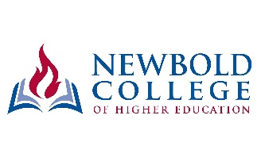
TRANS-EUROPEAN DIVISION
UNION APPLICATION FOR SPONSORSHIP ASSISTANCE
TO NEWBOLD COLLEGE OF HIGHER EDUCATION
________________________________________________________________

Complete one form for each student name to be consideration for TED Sponsorship assistance. Please answer all questions in full and return to the Education Department at the TED no later than Monday, 29th March 2021 for studies commencing in September 2021 (or Friday, 27th August 2021 for studies commencing in January 2022).

Please write in BLOCK CAPITALS

Name and address of Union:

Name of Student:

Email address of Student:

Name and Address of Conference /
Employing Organisation of Student:

STUDY PROGRAMMES FOR WHICH THIS STUDENT WILL BE REGISTERED
Year | Semester | Study Programmes  Please tick where appropriate in relevant Years and Semesters
 |  | BA / BD / Graduate Diploma | MA
 |  |  | Classwork (3 semesters) | Dissertation | Certificate of Missiology | Part-time | Leadership
Year 1 | August – December
 | January – May
 | June – July (Summer) | -
Year 2 | August – December
 | January – May
 | June – July (Summer) | -
Year 3 | August – December
 | January – May
 | June – July (Summer) | -
Newbold Accommodation |  | Single | Married | Number of children
Yes No

Date Sponsorship commences:

Date Sponsorship Ends:

Name of the School (if not Newbold):

Filled out by (Name and Position):

Signature and Date:

